A Context-aware Neural Hybrid Recommender System using Deep Learning for fixed-line telecommunication sector in Sri Lanka

Submitted by:

Madushanka H. W. C.

IM/2016/046

Supervised by:

Dr. Chathura Rajapaksha, Mr. Dinesh Asanka

The dissertation submitted in partial fulfilment of the requirements for the degree of Bachelor of Science (Honours) in Management and Information Technology

**Department of Industrial Management**

**Faculty of Science**

**University of Kelaniya**

**Sri Lanka**

**June, 2021**

**Table of content**

# 1. Title

A Context-aware Neural Hybrid Recommender System using Deep Learning for fixed-line telecommunication sector in Sri Lanka

# 2. Background of the Research

## 2.1. Telecommunication Industry in Sri Lanka

The telecommunication industry has become the center for digital growth and will continue to play the role of a disruptor. Today, terms like mobile, cloud, analytics broadband etc. have become a common lingo. According to [[Central Bank, 2020]](https://docs.google.com/document/d/1yyLHya-b0TjlwFbSq2BPUsodZbeDOS-auTT-qYasgqE/edit#bookmark=id.r0le4f4jn9rh), 10.9 million (34 per 100 people) internet users and 30.41 million mobile connections (1499 per 1000 people), equivalent to 141.7% of the total population, have been reported in Sri Lanka in January 2021. For example [[Sri Lanka Telecom PLC, 2020]](https://docs.google.com/document/d/1yyLHya-b0TjlwFbSq2BPUsodZbeDOS-auTT-qYasgqE/edit#bookmark=id.3g5sjwb6vai8) discusses that, the Sri Lanka Telecom PLC, a key player in Sri Lankan telecommunication industry, was having 9 million subscribers with a growing 91,119 million revenue by 2020.

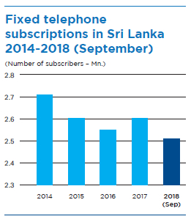

* Some factors about Dialog as well

The fixed-line telecommunication industry having 9 million+ customer base including multinational corporations, large and small corporate, retail and domestic customers. Though the massive customer awareness programs are coupled along with its products and services, the fixed line market faces intense competition from the mobile service providers while experiencing low response for its traditional core businesses. [Randiwela et. al., 2012]

In Sri Lanka youth which consists of 15-19, 20-24 and 25-29 age groups have the highest digital literacy accounts for 76.6%, 77.9% and 71.1% respectively as at June 2019. Thus, it is evident that Sri Lanka is also following the global trends with regards to digital behaviour. [Guruge et. al., 2020] As the digital behaviour of youth in Sri Lanka is growing significantly, need for telecommunication services in a satisfactory level for the youth, has arisen.

The annual growth of Sri Lankan internet usage and social media usage in 2017 was 7% and 22% respectively and 96% of Sri Lankan internet users are using Facebook. Thus, it is evident that the internet usage among youth is relatively high compared to other age groups irrespective of the country.[Guruge et. al., 2020] This states that recommendations of broadband internet services need to be more focused on youth (millennials) considering their demands and buying motives.

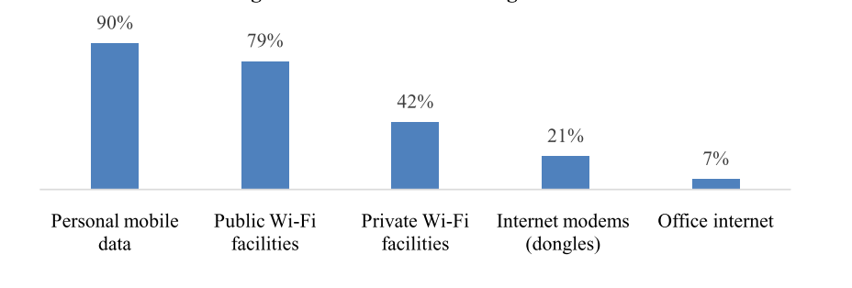

Source: Methods of Accessing Internet in Sri Lanka, by 2020, [Guruge et. al., 2020]

**\*\* cable TV users, and voice calls and IDD users**

With the advancements of big data, artificial intelligence and machine learning, a number of recommender systems have been implemented for retail, entertainment, social and other domains. In general, a recommender system uses historical data of purchases of products by other individuals to determine which to recommend to a particular customer. As [[Ivens et.al., 2018]](https://docs.google.com/document/d/1yyLHya-b0TjlwFbSq2BPUsodZbeDOS-auTT-qYasgqE/edit#bookmark=id.mbh77j5uqnxv) described, the field of recommender systems has its origins in the mid-1990s with the introduction of the Tapestry system. Content-based and collaborative filtering methods are popular techniques adopted in recommender systems. According to [[Ahmed et. al., 2019]](https://docs.google.com/document/d/1yyLHya-b0TjlwFbSq2BPUsodZbeDOS-auTT-qYasgqE/edit#bookmark=id.ymzmshah4ydg) and [[Khadiev et. al., 2016]](https://docs.google.com/document/d/1yyLHya-b0TjlwFbSq2BPUsodZbeDOS-auTT-qYasgqE/edit#bookmark=id.m76mlei415cq), collaborative filtering works by collecting user ratings for items in a given domain and calculating similarities between users or items in order to provide relevant recommendations. Content-based filtering uses item features to recommend other items similar to what the user likes, based on their previous actions or feedback. Each approach has both advantages and limitations, leading to several unsolved problems such as limited information retrieval, “cold-start”, “sparsity”, scalability problems, and overspecialization as described in [[Ivens et.al., 2018]](https://docs.google.com/document/d/1yyLHya-b0TjlwFbSq2BPUsodZbeDOS-auTT-qYasgqE/edit#bookmark=id.mbh77j5uqnxv) and [[Ahmed et. al., 2019]](https://docs.google.com/document/d/1yyLHya-b0TjlwFbSq2BPUsodZbeDOS-auTT-qYasgqE/edit#bookmark=id.ymzmshah4ydg).

Studies on recommendation systems have not much applied yet in the telecommunication domain. [[Chen C., 2016]](https://docs.google.com/document/d/1yyLHya-b0TjlwFbSq2BPUsodZbeDOS-auTT-qYasgqE/edit#bookmark=id.6a80qa9mexz) presents a recommendation algorithm in the mobile environment, but does not mention the corresponding architecture suitable for a mass-scale service provider. As [[Soft et. al., 2017] and](https://docs.google.com/document/d/1yyLHya-b0TjlwFbSq2BPUsodZbeDOS-auTT-qYasgqE/edit#bookmark=id.8b5f5gv8tp6q) [[Chen C., 2016]](https://docs.google.com/document/d/1yyLHya-b0TjlwFbSq2BPUsodZbeDOS-auTT-qYasgqE/edit#bookmark=id.6a80qa9mexz)identified, telecommunication data are highly asynchronous and significantly different compared to retail and other industries.

## 2.2 Research Problem

Due to high availability of telecom service providers and service packages, subscriber churn has increased.

Some services may pass unobserved. If they were recommended when needed, subscriber may continue with the career.

Loyal subscribers need to be identified and rewarded with cross-selling and up-selling offers.

Fixed-line telecommunication service providers face Gradual decline in the Broadband market share due to high competition. Lack of understanding forceful buying motives of their subscriber base, has led to the inability of providing needed services at the right time. Alo it may lead to unsuccessful marketing campaigns while some useful services or packages may be kept unaware. [Randiwela et. al., 2012]

Telecommunication services market in Sri Lanka is oligopolistic, and in the current market the number of service providers is very limited but yet the competition is very high. Even a good brand image helps to obtain a positive response in favour of the company from the buyer, being market leader not only guarantee the best sales, as past researches have shown that the modern generation has no brand loyalty. They switch the brand according to the facilities addressing their needs on time , quality of service, and fair prices provided by the brand. [Hayat et. al., 2020]

Further, [Popli et. al., 2013] has identified the factors affecting telecommunication service subscribers’ satisfaction as customer service, price fairness, sales promotions (ex: for voice services extra free minutes, limited offer to get double balance, free VAS, MMS at low rate etc) and coverage of services,

Recommendation need to be offered to the more beneficial subscriber groups.

Subscriber segmentation, identifying and prioritizing target subscriber groups, is crucial for enhancing the business value of recommendations offered.

A traditional user-interaction based recommender system won't be sufficient to to address this dynamic market and high competition in telecommunication industry,

Issues with Collaborative Filtering approach in a dynamic context (cold-start problem etc.)

User-service interactions, and demographics content alone won’t give accurate recommendations.

Awareness of Context (Contextual pre-filtering approach) is critical.

According to [Soft et. al., 2017], the increasing flourish of available telecommunication services offer more choices to the end user, leading some services to pass unobserved even if useful. In [Chen C., 2016] argues that, due to this high availability of options, subscriber churn has significantly increased. Acquiring new customers has become multiple times more expensive than retaining a customer. Therefore, segmentation of subscribers on their behavioral patterns and recommending services and offers to these identified beneficial groups of subscribers, will increase the business value while reducing subscriber churn. Although traditional recommender system approaches, where only the user-service interactions are incorporated, will not be able to meet these challenges. Therefore considering subscribers’ opinions and reviews of consumed services, would be helpful to provide more effective recommendations.

## 2.3 Justification of the research Problem

Due to high competition, and the huge variety of services available in telecommunication industry, a requirement has arised from service providers to implement a recommender system to recommend services to its beneficial subscribers to reduce subscriber churn and gain profits.

**Market share analysis: fixed-line telcom services providers in sri lanka**

* No of subscribers SLT has, no of subscribers Dialog PLC is getting, so there is a threat and competition. (SLT telecom 9 million subscribers by 2020)

**Factors affecting customers buying motives in Telecom domain?**

Even the SLT is the market leader.. Why is rapid market growth for other service providers could be seen? This justifies that Being the market leader has no or less effect on the modern generation(millennials), in other ways the modern generation has no brand loyalty.

They may switch the brand according to the facilities provided. Service quality and consistency, and the benefits, pricing will be key matters. [Hayat et. al., 2020]

**Why do customers churn? Why satisfaction is important?**

Why a telcom consumer may tend to churn? It can depend upon the switching cost and switching intentions. High switching cost discourages the customer from switching careers. Quality of service, fair pricing, brand image or consumer’s brand loyalty, and the satisfaction (transactional or cumulative) are identified as key factors which result in churn . [Hayat et. al., 2020]

Getting a new customer can cost five times as much as retaining an existing customer.

What is more, increasing customer retention by 5% can increase profits by 25-95%. The success rate of selling to the existing customer is 60-70% while the success rate of selling to the new customer is 5-20% only [Taylor, 2019].

Acquiring new customers has become multiple times more expensive than retaining a customer. [Chen C., 2016]

Management can know if their customers are satisfied or not from their exit and voice. Exit refers to when customers stop using the product/ service of the company and voice refers to the complaints of the customers.[Singh et. al., 2019]

According to [Soft et. al., 2017], as telecommunication services continuously providing different choices to the end user, leading some services to pass unobserved even if useful.

**Why is considering context important? What is the identified context?**

Internet usage: Is time context important?

According to [Guruge et. al., 2020] less than half of the respondents use night time data whereas more than one third use night time data occasionally. Furthermore, one in every five does not consume mobile data at all.

What context can be derived from call detail records (CDR) data? According to [Fernando et. al., 2018] Call Detail Records (CDRs) can broadly describe three dimensions of human behavior: social networks, consumption activity, and mobility

**Why is subscriber segmentation and prioritization important prior to a recommendation?**

**Why need to fill the gap?**

This study fills two gaps (practise gap and empirical gap)

A traditional user-interaction based recommender system won't be sufficient to to address this dynamic market and high competition in telecommunication industry,

There is a dearth of studies done in Sri Lanka in particular the telecom sector to implement a recommender system.

Telecom service market is highly volatile and service providers must understand the affecting factors, and need of recommendations.

## 2.4. About the Research

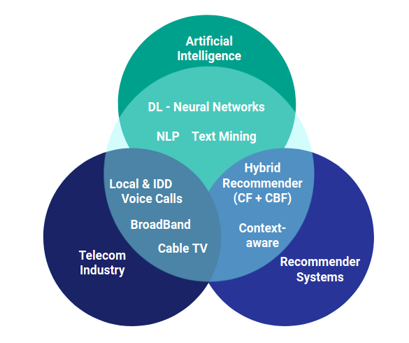

In [[Chen C., 2016]](https://docs.google.com/document/d/1yyLHya-b0TjlwFbSq2BPUsodZbeDOS-auTT-qYasgqE/edit#bookmark=id.6a80qa9mexz), discussed that every telecommunication service provider in the industry is seeking new opportunities to increase operational and marketing efficiency with available big data and machine learning techniques. Therefore, the proposed solution will compare the available recommender algorithms and select the most appropriate stack of models to develop a hybrid recommender system to recommend telecommunication services. Moreover, it will focus on segmenting and identifying beneficial subscriber groups to provide these personalised recommendations, to empower long-term customer relationships with reducing churn rates.

Data will be collected from a particular telecommunication operator, e.g. Sri Lanka Telecom PLC, including user demographics, service purchases and usage histories, interactions, CRM logs, and related network KPIs. An elementary survey will be conducted among a stratified sample selected from the mobile and broadband internet subscribers in Sri Lanka, to extract their opinions on offered services, and need of such recommendations. Data integration, cleansing and preprocessing tasks will be carried out on raw data retrieved, including extract, transform, load (ETL), and reconciliation processes as described in [[Bursha et. al., 2019]](https://docs.google.com/document/d/1yyLHya-b0TjlwFbSq2BPUsodZbeDOS-auTT-qYasgqE/edit#bookmark=id.h5uk8b4wnnlb).

The uplift modeling technique will be used for subscriber segmentation considering their service usage patterns. As [[Ahmed et. al., 2019]](https://docs.google.com/document/d/1yyLHya-b0TjlwFbSq2BPUsodZbeDOS-auTT-qYasgqE/edit#bookmark=id.ymzmshah4ydg) presented, it is a predictive modelling technique which calculates the probability of a potential subscriber response with positive impact, when a recommendation is provided, so that focus can be given to the subscribers with higher potential. Subscribers will be segmented as, “sure things” (who will purchase no matter what), “persuadables” (who will purchase only if a recommendation is given), “lost causes” (who will not purchase no matter what), and “sleepers” (who will not purchase even a recommendation is given).

According to [[Sundermann et. al., 2019]](https://docs.google.com/document/d/1yyLHya-b0TjlwFbSq2BPUsodZbeDOS-auTT-qYasgqE/edit#bookmark=id.ht4w5lr8c7ed) considering rich information embedded in users’ reviews into the recommender systems can produce more precise recommendations. Extracting user opinions from reviews (opinion mining) can be achieved through applying Natural Language Processing(NLP) based text analysis techniques to available CRM logs, and/or social media to gauge the sentiment about specific characteristics of a service consumed, which can be considered for the proposed model, when recommending telcom services.

As [[Ivens et.al., 2018]](https://docs.google.com/document/d/1yyLHya-b0TjlwFbSq2BPUsodZbeDOS-auTT-qYasgqE/edit#bookmark=id.mbh77j5uqnxv) and [[Yousef et. al., 2018]](https://docs.google.com/document/d/1yyLHya-b0TjlwFbSq2BPUsodZbeDOS-auTT-qYasgqE/edit#bookmark=id.tdt1vd8ybr2j) described, bayesian classifiers and decision trees are widely used in content-based approaches, while neighborhoods or the latent factor models, (e.g. matrix factorization, ALS) were used in collaborative filtering approaches. According to [[Soft et. al., 2017]](https://docs.google.com/document/d/1yyLHya-b0TjlwFbSq2BPUsodZbeDOS-auTT-qYasgqE/edit#bookmark=id.8b5f5gv8tp6q) and [[Afsar et. al., 2021]](https://docs.google.com/document/d/1yyLHya-b0TjlwFbSq2BPUsodZbeDOS-auTT-qYasgqE/edit#bookmark=id.mhrr7s3rhalm) associative classification, Artificial Neural Networks(ANN), and Reinforcement Learning based agents have been proposed recentlyfor recommender models. As [[Ivens et.al., 2018]](https://docs.google.com/document/d/1yyLHya-b0TjlwFbSq2BPUsodZbeDOS-auTT-qYasgqE/edit#bookmark=id.mbh77j5uqnxv) suggested, a confusion matrix, which illustrates the accuracy of the solution to a classification problem with the information about actual and predicted results, can be used to compare the performance of these algorithms. Then the most appropriate algorithms will be selected and improved. Therefore, an ensemble modeling approach is proposed to implement this hybrid recommender system. According to [[Aggarwal CC, 2016],](https://docs.google.com/document/d/1yyLHya-b0TjlwFbSq2BPUsodZbeDOS-auTT-qYasgqE/edit#bookmark=id.8hazobng5gi9) using ensemble modeling, the resulting outputs from the content-based, collaborative, and context-aware(opinion based) recommenders can be combined into a single and more robust output. Further, a web-based system with a REST API will be developed to demonstrate the predictions, insight visualizations and facilitate querying for recommendations for a specific user or a user group.

# 3. Literature Review

* *Literature review can be used to justify the need for your research, prove the originality and value of your contribution. It presents readers a thorough review of the existing literature on the subject.*
* *Here you may also review the state of the art relevant to your research. The idea is to present the major ideas in the state of the art right up to, but not including, your own personal ideas.*
* *Literature review for the proposal may be narrow enough to prompt or to generate seed ideas, but a comprehensive literature review must be presented in your dissertation.*

**Paragraphs:**

1. **Landline telecommunication services : introduction and factors affecting customers buying motives**
2. **Problem and justification (why need recommendation, why need subscriber segmentation and prioritization, why need to consider context in recommendation)**
3. **Recommendation techniques, theories/ hybrid approach , pros and cons as identified/ different methodologies and approaches suggested in related papers/ comparison and evaluation methodologies suggested/ factors to consider about suitability of selecting such techniques for telecom domain**
4. **Introducing Justifying the proposed solution, and explain readings about possible methodologies to consider**

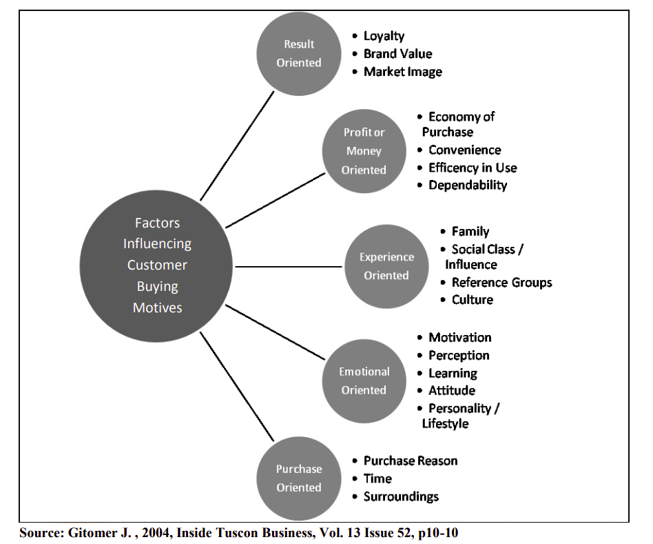

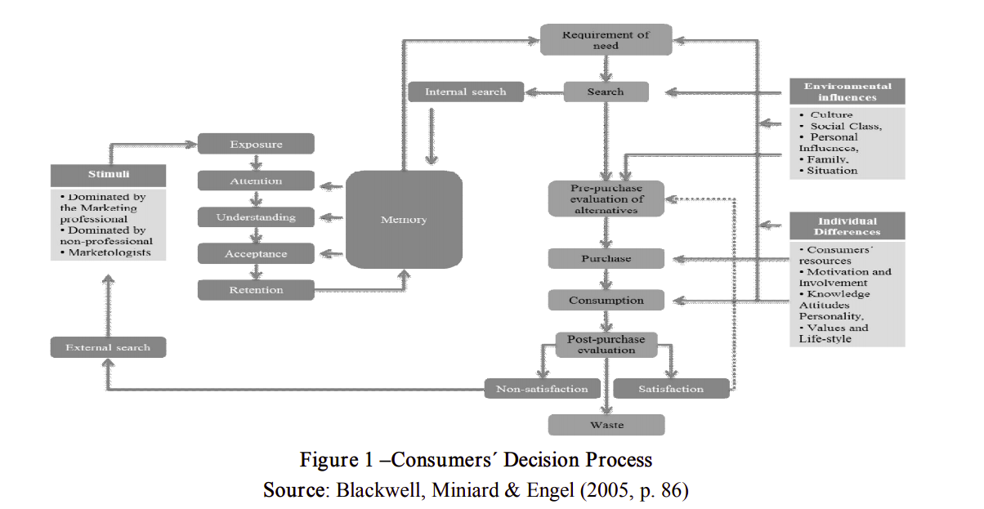

As [Randiwela et. al., 2012] explains, customer buying motives for a service or product can be categorized into two extremes, those which are operational and those which are sociopsychological. The paper further explains that the operational buying motives as those reasons for the purchase that are directly related to the anticipated performance of the product and sociopsychological motives as reasons for the purchase that are indirectly related to the anticipated performance of the product and directly related to the consumers social and psychological interpretation of the product. Moreover, the paper justifies that customer purchases are influenced strongly by cultural, social, personal, and psychological characteristics, So a buyers’ decision can be influenced by personal characteristics such as age, life-cycle stage, occupation, economic situation, life style, personality and self concept. Psychological factors including motivation, perception, learning, beliefs and attitudes are also should be taken as key concerns.

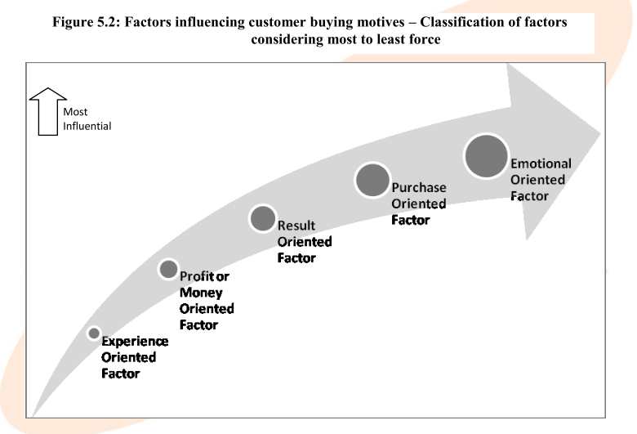

Source: Factors influencing customers’ buying motives - Classification of factors considering most to least force [Randiwela et. al., 2012]

# 4. Purpose of the Research

The purpose of the research is to implement a hybrid-recommender system, which is aware to the user content, interactions and other contextual factors, and able to provide accurate recommendations on fixed-line telecom services offered by the desired company, to its current subscribers.

Research Approach: Mixed approach (Qualitative, Quantitative)

Approach:

Deductive : Aims to prove existing theories within formulated hypothesis

Predictive: Provide predicted recommendations on past context





# 5. Objectives of the research

To analyze the relationship between telecommunication subscribers and telecommunication services (packages)

To identify the challenges telecommunication companies face that lead to high revenue loss, churn and bad customer experience.

To identify the factors affecting in recommending fixed-line telecom services to a subscriber (Voice calls, Broadband internet, cableTV).

To identify beneficial subscriber segments and determine which services/ packages are most applicable/ profitable targeting these segmented groups

To provide accurate recommendations considering user interactions and contextual information.

To suggest strategies to enhance cross-selling and up-selling of fixed-line telecom services among subscribers through accurate recommendations.

The main objective of this research is to *identify patterns using student movement data inside the University.*

Sub objectives are,

* Preprocessing the data set
* Mapping the dataset using visualizing tools and geographic information systems.
* Finding student behavior patterns

# 6. Expected Outcomes/Deliverables

*One of the expected outcomes would be, find a pattern in student movement which can be connected to situational leadership of the students.*

# 7. Methodology

**Methodology content**

* 1. **Conceptual framework**
  2. **Data gathering**
  3. **Independent variables and hypothesis defined**
  4. **Proposed Solution**
  5. **Proposed implementation methodology**
  6. **Proposed evaluation methodology**
  7. **Theories and technologies**

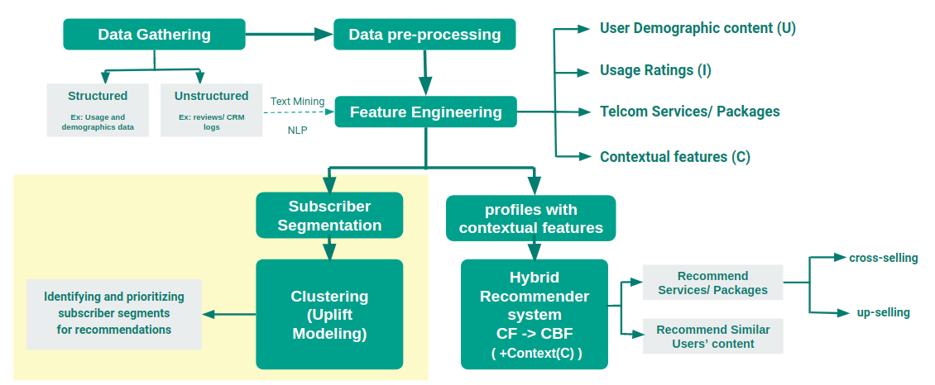

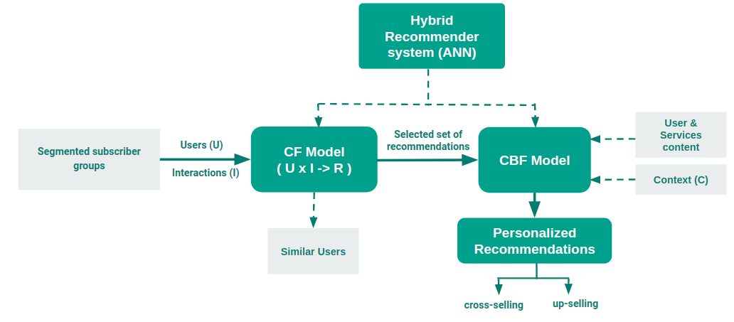

Proposed data gathering methodologies:

Telecommunication services usage data (cableTV, Voice calls (in-country, IDD) and Broadband Internet, demographic data of the registered subscribers, purchase histories and payment patterns data will be gathered from the selected telecommunication service provider, for the analytical purposes.

User context and opinions will be derived through the gathered data, and through a analysis through user reviews, inquiries and complaints collected via call center, CRM logs and other public forums.

In-depth discussions will be carried out with product development, data handling and marketing groups and internal staff within the selected telecommunication service provider.

Comprehensive survey will be carried out based on the targeted customer segments in the country.

As [Randiwela et. al., 2012] described, the sampling method used for this research is purposive sampling. Mainly sampling is been focused on micro level business customers along with the residential customers in professional and none-professional categories, where there is a huge competitive and potential market exists in all over the country. While sampling judgmental sampling has also been merged into the purposive sampling method where necessary.

Respective sample will be selected covering districts from the whole country, through university undergraduates and teenagers, the millenials who are vastly using these telecommunication products, their families, friends and relatives. Published telephone directories will be used as a resource when finding the targeted business and residential customers. Qualitative feedback will be gathered using five point lickert scale system (1 to 5, where 5 = “Strongly positive position” and 1 = “Strongly negative position)

Narrow down the products to be recommended using the proposed system, into landline services including, voice calls, cableTV and Broadband internet.

*The first phrase of the study will be a data preprocessing stage. The data is recorded in below format. With a suitable method to data preprocessing and feature extraction we can make this data meaningful.*

*To do the data preprocessing stage, the first thing would be identifying*

*Then we must categorize the*

*Next stage would be identifying the t*

*Next step would be mapping the preprocessed dataset.*

*After mapping we must analyze for patterns in*

# 8. Time Plan

|  |  |  |  |  |  |  |  |  |  |  |  |  |  |  |  |  |  |  |  |  |  |  |  |  |  |  |  |  |  |  |  |  |  |  |  |  |  |  |  |  |  |  |  |  |
| --- | --- | --- | --- | --- | --- | --- | --- | --- | --- | --- | --- | --- | --- | --- | --- | --- | --- | --- | --- | --- | --- | --- | --- | --- | --- | --- | --- | --- | --- | --- | --- | --- | --- | --- | --- | --- | --- | --- | --- | --- | --- | --- | --- | --- |
|  |  | **May** | | | | | | | | **June** | | | | | | | **July** | | | | | **August** | | | | | **September** | | | | **October** | | | | | **November** | | | | **December** | | | | |
|  | *Table 1 Time Plan*  **Semester 1** | | | | | | | | | | | | | | | | | | | | | | | | |  | **Semester 2** | | | | | | | | | | | | | | | | | |
| **Task** | **1** | **2** | **3** | | **4** | | **5** | | **6** | **7** | | **8** | | **9** | | **10** | **11** | **12** | **L** | | **L** | **Exam** | | | | **V** | **1** | **2** | **3** | **4** | **5** | **6** | **7** | **8** | **9** | **1**  **0** | **1**  **1** | **1**  **2** | **13** | **1**  **4** | **1**  **5** | **L** | **L** |  |
| Submission of the research topic |  |  |  | |  | |  | |  |  | |  | |  | |  |  |  |  | |  |  |  |  |  |  |  |  |  |  |  |  |  |  |  |  |  |  |  |  |  |  |  |  |
| Review of literature |  |  |  |  |  |  |  |  |  |  |  |  |  |  |  |  |  |  |  |  |  |  |  |  |  |  |  |  |  |  |  |  |  |  |  |  |  |  |  |  |  |  |  |  |
| Formulation of the research problem |  |  |  | |  | |  | |  |  | |  | |  | |  |  |  |  | |  |  |  |  |  |  |  |  |  |  |  |  |  |  |  |  |  |  |  |  |  |  |  |  |
| Defining the goal and  objectives |  |  |  | |  | |  | |  |  | |  | |  | |  |  |  |  | |  |  |  |  |  |  |  |  |  |  |  |  |  |  |  |  |  |  |  |  |  |  |  |  |
| Defining the methodology |  |  |  | |  | |  |  |  |  | |  | |  | |  |  |  |  | |  |  |  |  |  |  |  |  |  |  |  |  |  |  |  |  |  |  |  |  |  |  |  |  |
| Preparation of the research proposal |  |  |  | |  | |  | |  |  | |  | |  | |  |  |  |  | |  |  |  |  |  |  |  |  |  |  |  |  |  |  |  |  |  |  |  |  |  |  |  |  |
| Submission of the research proposal |  |  |  | |  | |  | |  |  | |  | |  | |  |  |  |  | |  |  |  |  |  |  |  |  |  |  |  |  |  |  |  |  |  |  |  |  |  |  |  |  |
| Proposal Presentation |  |  |  | |  | |  | |  |  | |  | |  | |  |  |  |  |  |  |  |  |  |  |  |  |  |  |  |  |  |  |  |  |  |  |  |  |  |  |  |  |  |
| Information collection and analysis |  |  |  | |  | |  | |  |  | |  | |  | |  |  |  |  | |  |  |  |  |  |  |  |  |  |  |  |  |  |  |  |  |  |  |  |  |  |  |  |  |
| Preparation of the first three chapters of the dissertation |  |  |  | |  | |  | |  |  | |  | |  | |  |  |  |  | |  |  |  |  |  |  |  |  |  |  |  |  |  |  |  |  |  |  |  |  |  |  |  |  |
| Submission of the first three chapters of the dissertation |  |  |  | |  | |  | |  |  | |  | |  | |  |  |  |  | |  |  |  |  |  |  |  |  |  |  |  |  |  |  |  |  |  |  |  |  |  |  |  |  |
| Progress review presentation |  |  |  | |  | |  | |  |  | |  | |  | |  |  |  |  | |  |  |  |  |  |  |  |  |  |  |  |  |  |  |  |  |  |  |  |  |  |  |  |  |
| Development of the conceptual model |  |  |  | |  | |  | |  |  | |  | |  | |  |  |  |  | |  |  |  |  |  |  |  |  |  |  |  |  |  |  |  |  |  |  |  |  |  |  |  |  |
| Testing and Validation |  |  |  | |  | |  | |  |  | |  | |  | |  |  |  |  | |  |  |  |  |  |  |  |  |  |  |  |  |  |  |  |  |  |  |  |  |  |  |  |  |
| Preparation of the final report |  |  |  | |  | |  | |  |  | |  | |  | |  |  |  |  | |  |  |  |  |  |  |  |  |  |  |  |  |  |  |  |  |  |  |  |  |  |  |  |  |
| Submission of preliminary soft-bound dissertation |  |  |  | |  | |  | |  |  | |  | |  | |  |  |  |  | |  |  |  |  |  |  |  |  |  |  |  |  |  |  |  |  |  |  |  |  |  |  |  |  |
| Final presentation |  |  |  | |  | |  | |  |  | |  | |  | |  |  |  |  | |  |  |  |  |  |  |  |  |  |  |  |  |  |  |  |  |  |  |  |  |  |  |  |  |

# 

# 9. References

|  |  |
| --- | --- |
| [Afsar et. al., 2021] | Afsar, M. Mehdi, et al. Reinforcement Learning Based Recommender Systems: A Survey. *University of Calgary, Calgary, AB Canada*, deepai.org/publication/reinforcement-learning-based-recommender-systems-a-survey, 15 Jan. 2021. |
| [Ahmed et. al., 2019] | Ahmed, A.A.Q., Maheswari, D. An enhanced ensemble classifier for telecom churn prediction using cost based uplift modelling. *Int. j. inf. tecnol. 11*, 381–391, 2019. |
| [Aggarwal CC, 2016] | Aggarwal CC (2016) Ensemble-based and hybrid recommender systems. *In: Recommender systems, Springer International Publishing Switzerland, pp 199–224, 2016* |
| [Bursha et. al., 2019] | Bushra Ramzan, Imran Sarwar Bajwa, Noreen Jamil, Riaz Ul Amin, Shabana Ramzan, Farhan Mirza, Nadeem Sarwar, "An Intelligent Data Analysis for Recommendation Systems Using Machine Learning", *Scientific Programming, vol. 2019*, Article ID 5941096, 20, 2019. |
| [Chen C., 2016] | Chen, C. (2016). Use cases and challenges in telecom big data analytics. *APSIPA Transactions on Signal and Information Processing*, 5, E19, 2016. |
| [Central Bank, 2020] | Central Bank of Sri Lanka, Sri Lanka Socio Economic Data 2020, *Statistics Department, Central Bank of Sri Lanka,* ISSN : 1391 – 3557, August 2020. |
| [Ivens et.al., 2018] | Ivens Portugal, Paulo Alencar, and Donald Cowan. The use of machine learning algorithms in recommender systems: A systematic review. E*xpertSystems with Applications 97 (2018)*, 205–227, 2018. |
| [Khadiev et. al., 2016] | Khadiev, K.; Zulfat, M.; Sidikov, M. Collaborative filtering approach in adaptive learning.Int. *J.Pharm. Technol*, 8, 15124–15132, 2016. |
| [Soft et. al., 2017] | Soft, M., Zulu, D., & Mazhandu, R. Recommender System for Telecommunication Industries: A Case of Zambia Telecoms. *American Journal of Economics*, 7, 271-273, 2017. |
| [Sri Lanka Telecom PLC, 2020] | Sri Lanka Telecom PLC. 2020 Annual Report Sri Lanka Telecom PLC. [online] Available at: <https://www.slt.lk/en/about-us/investors/financial-reports/annual> [Accessed 23 March 2021] |
| [Sundermann et. al., 2019] | Sundermann, C.; Domingues, M.; Sinoara, R.; Marcacini, R.; Rezende, S. Using Opinion Mining in Context-Aware Recommender Systems: A Systematic Review.*Information 2019*, 10, 42, 2019. |
| [Yousef et. al., 2018] | Yousef Kilani, Ahmed Fawzi Otoom, Ayoub Alsarhan, Manal Almaayah, A genetic algorithms-based hybrid recommender system of matrix factorization and neighborhood-based techniques, *Journal of Computational Science, Volume 28, Pages 78-93*, ISSN 1877-7503, 2018. |
| [Zui Zhang et. al., 2013] | Zui Zhang, Hua Lin, Kun Liu, Dianshuang Wu, Guangquan Zhang, Jie Lu, A hybrid fuzzy-based personalized recommender system for telecom products/services, *Information Sciences, Volume 235, Pages 117-129*, ISSN 0020-0255,, 2013. |
| [Seyednezhad et. al, 2018] | Seyednezhad, s. M. Mahdi & Cozart, Kailey & Bowllan, John & Smith, Anthony. A Review on Recommendation Systems: Context-aware to Social-based, 2018. |
| [Adomavicius et. al., 2011] | Adomavicius, G., Mobasher, B., Ricci, F., & Tuzhilin, A. Context-Aware Recommender Systems. AI Magazine, 32(3), 67-80, 2011. |
| [Covington et. al., 2016] | Covington, Paul, J. Adams and Emre Sargin. “Deep Neural Networks for YouTube Recommendations.” Proceedings of the 10th ACM Conference on Recommender Systems (2016): n. Pag. |
| [Xiangnan et. at., 2017] | He, Xiangnan & Liao, Lizi & Zhang, Hanwang. (2017). Neural Collaborative Filtering. Proceedings of the 26th International Conference on World Wide Web. |
| [Hayat et. al, 2020] | Hayat, H. M. U., Gunathilake, M. M. L. C., Senamanthila, D. S., & Samaradiwakara, P. C. Factors Affecting Brand Switching Behaviour of Millennials: Experience from the Sri Lankan Telecommunication Industry. 1(2), 47–73, 2020. |
| [Randiwela et. al., 2012] | Randiwela, P., & Widanachchi, T. S. (2012). Factors Influencing Customer Buying Motives ; With Special Reference To Sri Lanka Telecom Broadband .... In Cambridge Business & Economics Conference (Issue June, 2012). |
| [Tylor, 2019] | Taylor, L. (2019), Customer Retention Marketing vs Customer Acquisition Marketing, available at. https://www.outboundengine.com/blog/customer- retention-marketing-vs-customer-acquisition-marketing/  (accessed on 14  August 2020). |
| [Singh et. al., 2019] | Singh, A., & Ilavarasan, P. V. Predicting consumer’s complaint behavior in telecom service: An empirical study of India, Sri Lanka, and Bangladesh. In Smart Innovation, Systems and Technologies (Vol. 106). Springer Singapore. <https://doi.org/10.1007/978-981-13-1742-2_46>, 2019 |
| [Guruge et. al., 2020] | Dk, T., Guruge, M. C. B., & Nanayakkara, N. W. O. K. D. S. P. A Descriptive Analysis on Digital Behaviour of Young Adults in Sri Lanka. International Journal of Business and Management Invention (IJBMI) ISSN, 9(6), 58–67. <https://doi.org/10.35629/8028-0906055867>, 2020 |
| [Popli et. al., 2013] | Popli, G. S., & Madan, M. (2013). Determinants of Customer Satisfaction in Telecom Industry - A Study of Indian Telecom Industry. SSRN Electronic Journal, May. <https://doi.org/10.2139/ssrn.2277570> |
| [Fernando et. al., 2018] | Fernando, L., Lokanathan, S., Surendra, A., & Gomez, T. Predicting population-level socio-economic characteristics using Call Detail Records (CDRs) in Sri Lanka. Proceedings of the 4th International Workshop on Data Science for Macro-Modeling, DSMM 2018 - In Conjunction with the ACM SIGMOD/PODS Conference, 0–17. <https://doi.org/10.1145/3220547.3220549>, 2018 |